**GROUP ASSIGNMENT COVER SHEET**

| **Student ID Number** | **Surname** | **Given Names** |
| --- | --- | --- |
| 29787599 | Changgra | Alvin |
| 33538352 | Tandijaya | Jehezkiel Hardwin |
|  |  |  |
|  |  |  |
| **\*** Please include the names of all other group members. | | |
| **Unit name and code** | Advanced Database Technology (FIT5137) | |
| **Title of assignment** | A4 PTV | |
| **Lecturer/tutor** | David Taniar / Arif Hidayat | |
| **Tutorial day and time** | Monday 10:00-12:00 | **Campus Clayton** |
| **Is this an authorised group assignment? ✓ Yes ☐ No** | | |
| **Has any part of this assignment been previously submitted as part of another unit/course?** **☐ Yes ✓ No** | | |
| **Due Date 25 October 2023** | | **Date submitted** |

All work must be submitted by the due date. If an extension of work is granted this must be specified with the signature of the lecturer/tutor.

**Extension granted until (date) 27 October 2023 Signature of lecturer/tutor ................................................................**

Please note that it is your responsibility to retain copies of your assessments.

| ***Intentional plagiarism or collusion amounts to cheating under Part 7 of the Monash University (Council) Regulations***  **Plagiarism**: Plagiarism means taking and using another person’s ideas or manner of expressing them and passing them off as one’s own. For example, by failing to give appropriate acknowledgement. The material used can be from any source (staff, students or the internet, published and unpublished works).  **Collusion**: Collusion means unauthorised collaboration with another person on assessable written, oral or practical work and includes paying another person to complete all or part of the work.  Where there are reasonable grounds for believing that intentional plagiarism or collusion has occurred, this will be reported to the Associate Dean (Education) or delegate, who may disallow the work concerned by prohibiting assessment or refer the matter to the Faculty Discipline Panel for a hearing. |
| --- |
| **Student Statement:**   * I have read the university’s Student Academic Integrity [Policy](http://www.policy.monash.edu/policy-bank/academic/education/conduct/student-academic-integrity-policy.html) and [Procedures](http://www.policy.monash.edu/policy-bank/academic/education/conduct/student-academic-integrity-managing-plagiarism-collusion-procedures.html). * I understand the consequences of engaging in plagiarism and collusion as described in Part 7 of the Monash University (Council) Regulations http://adm.monash.edu/legal/legislation/statutes * I have taken proper care to safeguard this work and made all reasonable efforts to ensure it could not be copied. * No part of this assignment has been previously submitted as part of another unit/course. * I acknowledge and agree that the assessor of this assignment may for the purposes of assessment, reproduce the assignment and:  1. provide to another member of faculty and any external marker; and/or 2. submit it to a text matching software; and/or 3. submit it to a text matching software which may then retain a copy of the assignment on its database for the purpose of future plagiarism checking.  * I certify that I have not plagiarised the work of others or participated in unauthorised collaboration when preparing this assignment.   *Signature .............................................................................. Date……………………………………*  * delete (iii) if not applicable |

Signature Alvin Changgra Date: 27 October 2023 Signature ______________________________Date:________

Signature Jehezkiel Hardwin Tandijaya Date: 27 October 2023 Signature _______________________________Date:_______

Signature ___________________Date:_____________________ Signature _______________________________Date:_______

| **Privacy Statement**  The information on this form is collected for the primary purpose of assessing your assignment and ensuring the academic integrity requirements of the University are met. Other purposes of collection include recording your plagiarism and collusion declaration, attending to course and administrative matters and statistical analyses. If you choose not to complete all the questions on this form it may not be possible for Monash University to assess your assignment. You have a right to access personal information that Monash University holds about you, subject to any exceptions in relevant legislation. If you wish to seek access to your personal information or inquire about the handling of your personal information, please contact the University Privacy Officer: [privacyofficer@adm.monash.edu.au](mailto:privacyofficer@adm.monash.edu.au) |
| --- |

**FIT5137 S2 2023 Assignment 4: PTV Answer Sheet (Weight = 30%)**

**PLEASE SUBMIT ANSWER SHEET IN PDF FORMAT**

**Due date: Wednesday, 25 October 2023, 11:55pm**

Version: 2.0 – 25/09/2023

**Assignment Task list**

Your assignment consists of several parts. Always read the instruction one by one. Do not move to the step without completing the previous step:

* Task 1: Data Restoration - Restore the data to the database. Monitor the success indicator to ensure successful restoration of the data.
* Task 2: Data Preprocessing - Perform necessary structure maintenance and create result tables for further processing.
* Task 3: Data Analytics - Develop SQL queries to analyze the data and evaluate performance.
* Task 4: Data Visualization - Create visualizations to present the results of the data analytics.

**For simplicity, all the data required for this assignment is readily available in the PostGIS Docker container. You can access these datasets within the container by navigating to the /data/adata folder.If you don’t know how to do it, refer to the labs 10 activities. As a data analyst, it is your responsibility to understand and explore these publicly available data.**



Verify your data before the restoration process.

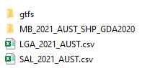

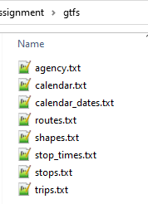 

**As a data analyst, it is your responsibility to understand and explore these publicly available data.**

**Do not edit or remove any content on the answer sheet, including the questions**. Please write your answers in the answer boxes provided. If necessary, you can adjust the size of the answer box to fit your answer.

## Task 1: Data Restoration

Before you can start the data analytic processes, the first thing you have to do is to restore the external data to your database. Make sure you prepare a destination schema to restore your data. The destination schema for your assignment is “**ptv**”.

Note:

* Before initiating the data restoration process, **it is essential to thoroughly explore the dataset**. This exploration involves identifying appropriate data types, determining field lengths, and making other relevant considerations that will inform the creation of the table structure.
* Ensure that you restore the data into the PTV schema using regular (local) tables. Do not utilize foreign tables, as the data must be stored directly within the PostgreSQL database – updated 27/09/2023
* Make sure all 8 GTFS tables are restored successfully
* Index or constraints can be added to the table after the data has been restored completely

(Note: This index or constraint requirement is **NOT** mandatory in this Task 1 – updated 25/09/2023)

* **No data cleaning required for this assignment**
* For more information, see the FAQ for Assignment 4.

### **1.1 PTV schema**

Write the SQL script to create the destination schema named “**ptv**”.

| create schema ptv; |
| --- |

### **1.2 GTFS**

Write the SQL script to restore **ALL** tables in GTFS files.

| --1.2  -- Create & Import Agency Table  create table ptv.agency(  agency_id numeric,  agency_name varchar,  agency_url varchar,  agency_timezone varchar,  agency_lang varchar  );  COPY ptv.agency FROM '/data/adata/gtfs/agency.txt' DELIMITER ',' CSV HEADER;  -- Create & Import Routes Table  create table ptv.routes(  route_id varchar,  agency_id numeric,  route_short_name varchar,  route_long_name varchar,  route_type numeric,  route_color varchar,  route_text_color varchar  );  COPY ptv.routes FROM '/data/adata/gtfs/routes.txt' DELIMITER ',' CSV HEADER;  -- Create & Import Calendar Table  create table ptv.calendar(  service_id varchar,  monday numeric,  tuesday numeric,  wednesday numeric,  thursday numeric,  friday numeric,  saturday numeric,  sunday numeric,  start_date date,  end_date date  );  COPY ptv.calendar FROM '/data/adata/gtfs/calendar.txt' DELIMITER ',' CSV HEADER;  -- Create & Import Calendar_Dates Table create table ptv.calendar_dates(  service_id varchar,  date date,  exception_type numeric  );  COPY ptv.calendar_dates FROM '/data/adata/gtfs/calendar_dates.txt' DELIMITER ',' CSV HEADER;  -- Create & Import Shapes Table create table ptv.shapes(  shape_id varchar,  shape_pt_lat float,  shape_pt_lon float,  shape_pt_sequence numeric,  shape_dist_traveled float  );  COPY ptv.shapes FROM '/data/adata/gtfs/shapes.txt' DELIMITER ',' CSV HEADER;  -- Create & Import Stop_Times Table create table ptv.stop_times(  trip_id varchar,  arrival_time varchar,  departure_time varchar,  stop_id varchar,  stop_sequence numeric,  stop_headsign varchar,  pickup_type numeric,  drop_off_type numeric,  shape_dist_travelerd varchar  );  COPY ptv.stop_times FROM '/data/adata/gtfs/stop_times.txt' DELIMITER ',' CSV HEADER;  -- Create & Import Stops Table create table ptv.stops(  stop_id varchar,  stop_name varchar,  stop_lat float,  stop_lon float  );  COPY ptv.stops FROM '/data/adata/gtfs/stops.txt' DELIMITER ',' CSV HEADER;  -- Create & Import Trips Table create table ptv.trips(  route_id varchar,  service_id varchar,  trip_id varchar,  shape_id varchar,  trip_headsign varchar,  direction_id numeric  );  COPY ptv.trips FROM '/data/adata/gtfs/trips.txt' DELIMITER ',' CSV HEADER; |
| --- |

### **1.3 ABS Mesh Blocks**

Scripts to restore the Mesh Blocks files by using correct dataset file. Restore the file using ogr2ogr into table “**mb2021**”

| ogr2ogr PG:"dbname=gisdb user=postgres" "/data/adata/MB_2021_AUST_SHP_GDA2020/MB_2021_AUST_GDA2020.shp" -nln ptv.mb2021 -overwrite -nlt MULTIPOLYGON |
| --- |

### **1.4 ABS Allocation Files**

Write the SQL script to restore the LGA2021 Allocation file.

| create table ptv.lga2021(  mb_code_2021 varchar,  lga_code_2021 varchar,  lga_name_2021 varchar,  state_code_2021 varchar,  state_name_2021 varchar,  aus_code_2021 varchar,  aus_name_2021 varchar,  area_albers_sqkm float,  asgs_loci_uri_2021 varchar  );  COPY ptv.lga2021 FROM '/data/adata/LGA_2021_AUST.csv' DELIMITER ',' CSV HEADER; |
| --- |

Write the SQL script to restore the SAL 2021 Allocation file for suburb2021.

| create table ptv.sal2021(  mb_code_2021 varchar,  sal_code_2021 varchar,  sal_name_2021 varchar,  state_code_2021 varchar,  state_name_2021 varchar,  aus_code_2021 varchar,  aus_name_2021 varchar,  area_albers_sqkm float,  asgs_loci_uri_2021 varchar  );  COPY ptv.sal2021 FROM '/data/adata/SAL_2021_AUST.csv' DELIMITER ',' CSV HEADER; |
| --- |

The allocation tables have 1-N relationship with the mb2021 in mb_code21 – mb_code_2021. Although there are no PK – FK defined in the table, the relationship rule still apply.

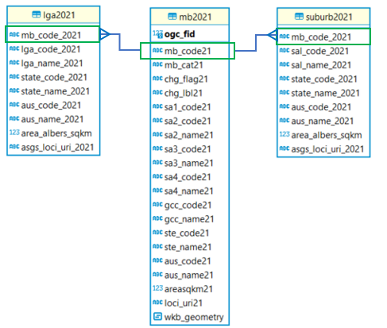

### **1.5 Data Verification**

Verify your restoration by running this script. 1.Do not modify the verification script. 2.Make sure that the table name is consistent with the table we provided.

Output: Attach a screenshot of the results to include all tables you have restored in Task 1.

| **with** tbl **as**  (**select** table_schema, TABLE_NAME  **from** information_schema.**tables**  **where** table_schema **in** ('ptv'))  **select** table_schema, TABLE_NAME,  (**xpath**('/row/c/text()', **query_to_xml**(format('select count(*) as c from %I.%I', table_schema, TABLE_NAME), **FALSE**, **TRUE**, '')))[1]::**text**::**int** **AS** rows_n  **from** tbl  **order** **by** table_name; |
| --- |

Screenshot:

|  |
| --- |

## Task 2: Data Preprocessing

### **2.1 Filter Melbourne Metropolitan area**

The mb2021 table contains whole mesh blocks in Australia. To minimise the query cost, we want to ensure that you only use the mesh blocks in Melbourne Metropolitan. The Melbourne Metropolitan’s mesh blocks can be identified from the gcc_name21. If the column contains “Greater Melbourne”, this mesh block is located in Melbourne Metropolitan.

Create a table named “**mb2021_mel**” that contains ONLY the mesh blocks in Melbourne Metropolitan.

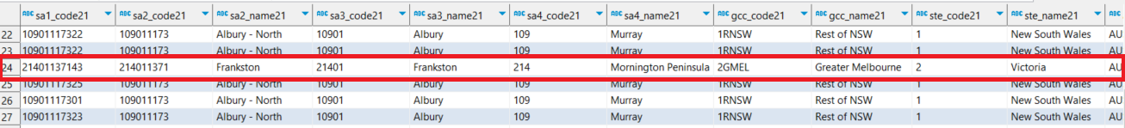

Write the SQL script to do this.

| create table ptv.mb2021_mel as  (  select * from ptv.mb2021  where lower(gcc_name21) = lower('Greater Melbourne')  ); |
| --- |

Attach a screenshot of the Spatial Map results.

Screenshot:

|  |
| --- |

### **2.2 Melbourne Metropolitan Boundary**

Since the working area will be Melbourne Metropolitan, it is important to have a polygon for the boundary of our working area. Create a table, named “**melbourne**” for Melbourne Metropolitan boundary.   
Hint: aggregate all mesh blocks polygon to create one large polygon for Melbourne Metropolitan boundary.

Write the SQL script to do this.

| create table ptv.melbourne as  (  select st_union(wkb_geometry) from ptv.mb2021_mel  ); |
| --- |

Attach a screenshot of the Spatial Map results.

|  |
| --- |

### **2.3 Add Geometry column to Stops table**

Stops table does not have any geometry column. Add a geometry column by using the latitude and longitude value that are available in the table. Make sure you use GDA2020 (SRID:7844) for this column.

Write the SQL script to do this.

| -- Add Geometry Column to Stops table  -- Step 1 Alter new column  alter table ptv.stops  add geom geometry;  -- Update the geom with the geom value from their lon and lat  update ptv.stops  set geom = ST_SetSRID(ST_MakePoint(stop_lon, stop_lat), 7844); |
| --- |

Attach a screenshot of the Spatial Map results.

|  |
| --- |

### **2.4 Denormalise GTFS structure**

The ptv.stops table does not show direct information regarding the vehicle types, routes_short_name and routes_long_name. These information are stored in the routes table.

Create a table called "stops_routes_mel" to encompass the following attributes: stop_id, stop_name, coordinates, route number (derived from routes_short_name), route name (derived from routes_long_name), and vehicle type. This data set should encompass all stops within the Melbourne Metropolitan area.

The vehicle type is determined by the corresponding route type, where:

* 0 corresponds to tram
* 2 corresponds to train
* 3 corresponds to bus
* Any other route type is labeled as 'Unknown'.

Use this figure as an example of expected result. (Note:Data value is for demonstration purposes only.)

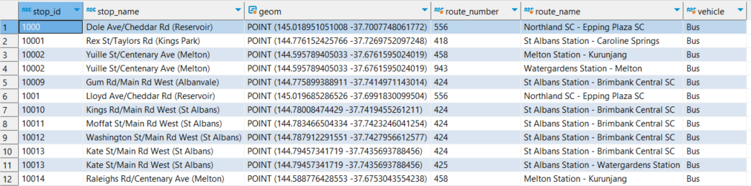

Make sure you remove any duplications in your result.

Write your SQL query here

| create table ptv.stops_routes_mel as  (  select distinct s.stop_id, s.stop_name, s.geom , r.route_short_name as "route_number", r.route_long_name as "route_name",  case  when r.route_type = 0 then 'Tram'  when r.route_type = 2 then 'Train'  when r.route_type = 3 then 'Bus'  else 'Unknown'  end as Vehicle  from ptv.stops s  join ptv.stop_times st on s.stop_id = st.stop_id  join ptv.trips t on st.trip_id = t.trip_id  join ptv.routes r on t.route_id = r.route_id  ); |
| --- |

Please complete the following statistics from **stops_routes_mel** table:

**Question 2.4.1**:How many rows do you have in the stops_routes_mel table?

Write the SQL script to do this and attach a screenshot of the query

| select count(*) from ptv.stops_routes_mel; |
| --- |

Screenshot

|  |
| --- |

**Question 2.4.2**:How many unique stop_ids do you have in the stops_routes_mel table?

Write the SQL script to do this and attach a screenshot of the query

| select count(distinct(stop_id)) from ptv.stops_routes_mel; |
| --- |

Screenshot

|  |
| --- |

## Task 3: Data Analytics

### **3.1 Suburbs Accessibility**

Create an SQL query to identify the **number of bus stops** in each Suburb. Your result should have the suburb name and the total bus stops in it.

Hint :

* identify the mesh block location of a bus stop. Then, aggregate the number in Suburb level.
* One suburb consists of multiple mesh blocks

Write your SQL query here

| WITH BusStops AS (  -- Filter out stops where the vehicle is a 'Bus'  SELECT stop_id, geom  FROM ptv.stops_routes_mel  WHERE vehicle= 'Bus'  ),  BusStopsWithMB AS (  -- Join bus stops with mesh blocks based on spatial location  SELECT b.stop_id, m.mb_code21, m.sa2_name21  FROM BusStops b  JOIN ptv.mb2021_mel m ON ST_Contains(m.wkb_geometry, b.geom)  )  -- Join with sal2021 to get the suburb name and count the bus stops  SELECT s.sal_name_2021 AS suburb_name, COUNT(b.stop_id) AS total_bus_stops  FROM BusStopsWithMB b  JOIN ptv.sal2021 s ON b.mb_code21 = s.mb_code_2021  GROUP BY s.sal_name_2021  ORDER BY total_bus_stops DESC; |
| --- |

Provide the screenshot of your **execution plan** and the real **execution time** for this query. You can get the real execution time under your result set.

Note:

* Execution plan can be found in SQL Editor -> Explain Execution Plan
* The execution time is shown in the screenshot below.(Note: the screenshot is for demonstration purposes only)  
  

| Execution plan : |
| --- |

| Execution time : |
| --- |

You are now tasked with devising an approach to enhance your query execution and minimize execution time. Provide a comprehensive explanation of your strategy, accompanied by the SQL script outlining the measures you've taken to optimize query performance. Additionally, include a screenshot showcasing the execution plan and execution time, effectively visualizing the enhancements achieved following the optimization.

| Strategy and SQL script:  **Strategy:** Due to the nature of the complexity with performing spatial operations, we have decided to modify some parts of the logic inside the queries that significantly improves our code in fetching the required query.   1. Firstly, we introduce what is called spatial indexing. This ensures that spatial indexes exist on the spatial columns which significantly speed up spatial queries that are essentially involved in the spatial operations. Though, it seems like the indexes created are redundant inside the queries. These indexes are implicitly used by the database engine when performing the spatial operations on the BoundingBox check logic. 2. Which comes on our second modification that is the BoundingBoxJoin. Instead of directly using ST_Contains function to determine if a mesh block contains a bus stop which was used in BusStopsWithMB on the non-optimised queries, it performs a simpler bounding box check of (b.geom && m.wkb_geometry). This checks if the bounding boxes of the two geometries overlap. Not only these checks are less computationally intensive than the detailed spatial checks, the spatial indexes that have been introduced earlier help the spatial operations to quickly narrow down potential matches, without the need of scanning the entire table which results in slow and inefficient operations.   **SQL Script:**  -- OPTIMIZED 3.1  -- Ensure spatial indexes exist on the spatial columns  CREATE INDEX IF NOT EXISTS idx_stops_routes_mel_geom ON ptv.stops_routes_mel USING GIST(geom);  CREATE INDEX IF NOT EXISTS idx_mb2021_mel_wkb_geometry ON ptv.mb2021_mel USING GIST(wkb_geometry);  -- Filter first: Create a temporary table with only bus stops  WITH BusStops AS (  SELECT stop_id, geom  FROM ptv.stops_routes_mel  WHERE vehicle = 'Bus'  ),  -- Use bounding box checks before detailed spatial checks  BoundingBoxJoin AS (  SELECT b.stop_id, m.mb_code21, m.sa2_name21  FROM BusStops b  JOIN ptv.mb2021_mel m ON b.geom && m.wkb_geometry -- Bounding box check  WHERE ST_Contains(m.wkb_geometry, b.geom) -- Detailed spatial check  )  -- Final aggregation  SELECT s.sal_name_2021 AS suburb_name, COUNT(b.stop_id) AS total_bus_stops  FROM BoundingBoxJoin b  JOIN ptv.sal2021 s ON b.mb_code21 = s.mb_code_2021  GROUP BY s.sal_name_2021  ORDER BY total_bus_stops DESC; |
| --- |

| Improved Execution plan : |
| --- |

| Improved Execution Time : |
| --- |

**Question 3.1.1**: Provide a list of the five suburbs with the lowest count of stops. In case multiple suburbs share the same minimum number of stops in your findings, arrange them in ascending order based on their suburb names.

Write the SQL script to do this and attach a screenshot of the query

| -- 3.1.1  -- Ensure spatial indexes exist on the spatial columns  CREATE INDEX IF NOT EXISTS idx_stops_routes_mel_geom ON ptv.stops_routes_mel USING GIST(geom);  CREATE INDEX IF NOT EXISTS idx_mb2021_mel_wkb_geometry ON ptv.mb2021_mel USING GIST(wkb_geometry);  -- Filter first: Create a temporary table or CTE with only bus stops  WITH BusStops AS (  SELECT stop_id, geom  FROM ptv.stops_routes_mel  WHERE vehicle = 'Bus'  ),  -- Use bounding box checks before detailed spatial checks  BoundingBoxJoin AS (  SELECT b.stop_id, m.mb_code21, m.sa2_name21  FROM BusStops b  JOIN ptv.mb2021_mel m ON b.geom && m.wkb_geometry -- Bounding box check  WHERE ST_Contains(m.wkb_geometry, b.geom) -- Detailed spatial check  )  -- Final aggregation  SELECT s.sal_name_2021 AS suburb_name, COUNT(b.stop_id) AS total_bus_stops  FROM BoundingBoxJoin b  JOIN ptv.sal2021 s ON b.mb_code21 = s.mb_code_2021  GROUP BY s.sal_name_2021  ORDER BY total_bus_stops ASC, s.sal_name_2021 ASC  LIMIT 5; |
| --- |

Screenshot

|  |
| --- |

**Question 3.1.2**: Average number of distinct stops in suburb

Write the SQL script to do this and attach a screenshot of the query

| -- 3.1.2  -- Ensure spatial indexes exist on the spatial columns  CREATE INDEX IF NOT EXISTS idx_stops_routes_mel_geom ON ptv.stops_routes_mel USING GIST(geom);  CREATE INDEX IF NOT EXISTS idx_mb2021_mel_wkb_geometry ON ptv.mb2021_mel USING GIST(wkb_geometry);  -- Filter first: Create a temporary table with only bus stops  WITH BusStops AS (  SELECT stop_id, geom  FROM ptv.stops_routes_mel  WHERE vehicle = 'Bus'  ),  -- Use bounding box checks before detailed spatial checks  BoundingBoxJoin AS (  SELECT b.stop_id, m.mb_code21, m.sa2_name21  FROM BusStops b  JOIN ptv.mb2021_mel m ON b.geom && m.wkb_geometry -- Bounding box check  WHERE ST_Contains(m.wkb_geometry, b.geom) -- Detailed spatial check  ),  -- Aggregation by suburb  SuburbStops AS (  SELECT s.sal_name_2021 AS suburb_name, COUNT(DISTINCT b.stop_id) AS distinct_bus_stops  FROM BoundingBoxJoin b  JOIN ptv.sal2021 s ON b.mb_code21 = s.mb_code_2021  GROUP BY s.sal_name_2021  )  -- Calculate the average  SELECT AVG(distinct_bus_stops) AS average_distinct_stops_per_suburb  FROM SuburbStops; |
| --- |

Screenshot

|  |
| --- |

### **3.2 LGA Blankspot**

The next step is to evaluate the **residential area** **without Bus Stops**. The residential area without any Bus Stops in it is considered as the **Blankspot**. Each mesh block has a distinct category. The category is defined in “**mb_cat21**” column, mb2021_mel table. In this task, your duty is to identified the percentage of blankspot in every city council or LGA. Below is the blankspot example in Kingsbury.

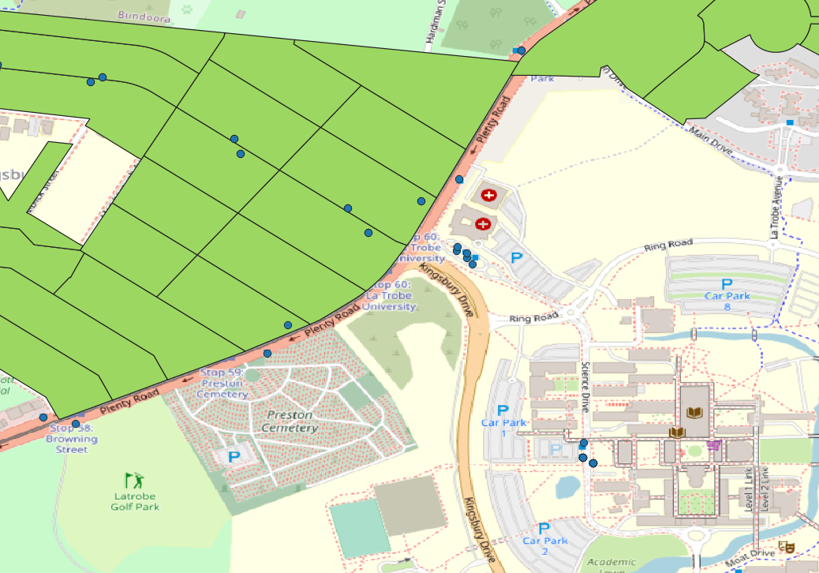

Let B as the number of residential blankspot, R as the total number of Residential Mesh Blocks, where B ⊆ R. The percentage of blankspot X in every LGA can be calculated using the following formula

$X=\frac{∑B}{∑R}*100\%$

Display the LGA name, total number of Residential Mesh Blocks, total number of residential blankspot, percentage of blankspot in Melbourne Metropolitan. Sort results in ascending order by total number of Residential Mesh Blocks.

Write the SQL script to do this and attach a screenshot of the query

| -- 3.2 LGA BLANKSPOT  -- Ensure spatial indexes exist on the spatial columns  CREATE INDEX IF NOT EXISTS idx_stops_routes_mel_geom ON ptv.stops_routes_mel USING GIST(geom);  CREATE INDEX IF NOT EXISTS idx_mb2021_mel_wkb_geometry ON ptv.mb2021_mel USING GIST(wkb_geometry);  -- Filter first: Create a temporary table or CTE with only bus stops  WITH BusStops AS (  SELECT stop_id, geom  FROM ptv.stops_routes_mel  WHERE vehicle = 'Bus'  ),  -- Identify mesh blocks without bus stops  MeshBlocksWithoutStops AS (  SELECT m.mb_code21  FROM ptv.mb2021_mel m  LEFT JOIN BusStops b ON m.wkb_geometry && b.geom  WHERE ST_Contains(m.wkb_geometry, b.geom) IS FALSE  AND m.mb_cat21 = 'Residential'  ),  -- Calculate the blankspot percentage for each LGA  BlankspotStats AS (  SELECT  l.lga_name_2021 AS lga_name,  COUNT(DISTINCT m.mb_code21) AS total_residential_meshblocks,  COUNT(DISTINCT ms.mb_code21) AS blankspots  FROM ptv.mb2021_mel m  JOIN ptv.lga2021 l ON m.mb_code21 = l.mb_code_2021  LEFT JOIN MeshBlocksWithoutStops ms ON m.mb_code21 = ms.mb_code21  WHERE m.mb_cat21 = 'Residential'  AND l.lga_name_2021 LIKE 'Melbourne%'  GROUP BY l.lga_name_2021  )  -- Display the results  SELECT  lga_name,  total_residential_meshblocks,  blankspots,  (blankspots::FLOAT / total_residential_meshblocks) * 100 AS blankspot_percentage  FROM BlankspotStats |
| --- |

Screenshot

|  |
| --- |

**Question 3.2.1**: Complete the following statistical data based on the result.

Note:

* The query and screenshot are not required for this section. You can write down your results directly
* If more than one suburb has the same percentage of blankspots, sort them by suburb name in ascending order.

| Criteria | Answer |
| --- | --- |
| Top 5 LGAs with the highest % of blankspots | 1. Yarra Ranges 2. Manningham 3. Bayside (Vic.) 4. Whitehorse 5. Greater Dandenong |
| Top 5 LGAs with the lowest % of blankspots | 1. Yarra 2. Melbourne 3. Stonnington 4. Port Phillip 5. Murrindindi |
| Average % of blankspots | 23.52455 % |

## Task 4: Data Visualisation

In this task, you are required to incorporate a heatmap visualization.

### **4.1 LGA Blankspot Analysis**

In this task, you will put the blankspot percentage in the heatmap. Provide the segmentation as follow:

* + X ≤ 20 %
  + 20% < X ≤ 40%
  + 40% < X ≤ 60%
  + 60% < X ≤ 80%
  + X > 80%

Write an SQL query to create a table named 'lga_blankspot' containing the blankspot percentages categorised by the LGA from the previous task 3.2 and sufficient spatial data. And attach a screenshot of the table contents.

Note: Ensure that this table is structured to facilitate the creation of a visual heat map specifically for the Melbourne region.

| CREATE TABLE ptv.lga_blankspot AS  (  -- CTE (Common Table Expression) to filter out only bus stops from the stops_routes_mel table  WITH BusStops AS (  SELECT stop_id, geom  FROM ptv.stops_routes_mel  WHERE vehicle = 'Bus'  ),  -- CTE to identify mesh blocks that are residential but don't have any bus stops  MeshBlocksWithoutStops AS (  SELECT m.mb_code21  FROM ptv.mb2021_mel m  LEFT JOIN BusStops b ON m.wkb_geometry && b.geom  WHERE ST_Contains(m.wkb_geometry, b.geom) IS FALSE  AND m.mb_cat21 = 'Residential'  ),  -- CTE to calculate blankspot statistics for each LGA  BlankspotStats AS (  SELECT  lga.lga_name_2021 AS lga_name,  ST_Union(mb.wkb_geometry) AS lga_geom, -- Aggregating the geometries of the mesh blocks for each LGA  COUNT(DISTINCT mb.mb_code21) AS total_residential_meshblocks,  COUNT(DISTINCT CASE WHEN mws.mb_code21 IS NOT NULL THEN mb.mb_code21 ELSE NULL END) AS blankspots  FROM ptv.mb2021_mel mb  JOIN ptv.lga2021 lga ON mb.mb_code21 = lga.mb_code_2021  LEFT JOIN MeshBlocksWithoutStops mws ON mb.mb_code21 = mws.mb_code21  WHERE mb.mb_cat21 = 'Residential'  GROUP BY lga.lga_name_2021  )  -- Selecting the final results from the BlankspotStats CTE, computing the blankspot percentage, and including the aggregated geometry  SELECT  lga_name,  lga_geom,  total_residential_meshblocks,  blankspots,  (blankspots::FLOAT / total_residential_meshblocks) * 100 AS blankspot_percentage  FROM BlankspotStats  ); |
| --- |

Screenshot

|  |
| --- |

Provide the screenshot for the heatmap by using QGIS. Please note that the heatmap is map-based and visually represents the distribution of blankspot percentages across different LGAs in the Melbourne region.

Remember to include appropriate labels, titles, and legends in your visualizations to make them easy to understand (Updated 05/10/2023)

|  |
| --- |

***End***

| **FIT5137**  **Assignment 4 Group Contract & Contribtution form** |
| --- |

**Note: One group consists of ONE or TWO or THREE students from the same lab you have enrolled in.**

**Lab No and time: FIT5137(3). Monday, 10.00-12.00**

**Tutor: Arif Hidayat**

| **Name: Alvin Changgra**  **Email address: acha0054@student.monash.edu** |
| --- |

| **Name(optional): Jehezkiel Hardwin Tandijaya**  **Email address (optional): jtan0382@student.monash.edu** |
| --- |

| **Name(optional):**  **Email address (optional):** |
| --- |

As a member of the team, I understand that:

* I will contribute to ***each***of the tasks within Assignment 4;
* I will attend and contribute at all agreed team meetings;
* I will respond in a timely manner (within 24 hours) to my fellow team members when they make contact;
* I will make every effort to resolve any issues that arise within the group, and raise, if necessary, any problems with my tutor ***before*** the due date;
* If I do not participate adequately, the tutor will be informed and will take appropriate action;
* I understand that part of the grade for this assignment will involve peer review where my partner will grade me on my participation and quality of contribution;
* **My mark for this assignment will reflect the quality of my work and my participation within the team.**

**Signed:** Alvin Changgra **Name:** Alvin Changgra **Date:** 26 October 2023

**Signed:** Jehezkiel Hardwin Tandijaya **Name:** Jehezkiel Hardwin Tandijaya **Date:** 26 October 2023

**Signed:** **Name:** **Date:**



**Please fill in the form with the contribution from each student towards the assignment.**

Note: A sample contribution declaration form is available on the Ed Forum site.

**1 NAME AND CONTRIBUTION DETAILS**

| Student ID | Student Name | Contribution Percentage |
| --- | --- | --- |
| 29787599 | Alvin Changgra | 50 |
| 33538352 | Jehezkiel Hardwin Tandijaya | 50 |
|  |  |  |

| **Please list the tasks you have done in this table** | | |
| --- | --- | --- |
| Student ID:29787599 | Student ID(optional): 33538352 | Student ID(optional): |
| 1-4 | 1-4 |  |

**2 DECLARATION**

**We declare that:**

* The information we have supplied in or with this form is complete and correct.
* We understand that the information we have provided in this form will be used for individual assessment of the assignment.
* The contribution percentage cannot be changed once you submit.

**3 SIGNATURE**



**Signatures**





**Date**